**INTEGRATED PROJECT REPORT**

**On**

**GAS LEAKAGE DETECTOR USING ARDUINO**

Submitted in partial fulfillment of the requirement for the

Course Integrated Project III (CSP2208) of

**COMPUTER SCIENCE AND ENGINEERING**

**B.E. Batch-2016**

**in**

**May-2018**



|  |  |
| --- | --- |
|  | **Submitted By** |
|  | **Harleen Kaur Mander** |
|  | **1610991342** |
|  | **Drishti Setia** |
|  | **1610991290** |
|  | **Harshita Aggarwal** |
|  | **1610991357** |
|  | **Harsimran Gill** |
|  | **1610991359** |

**DEPARTMENT OF COMPUTER SCIENCES**

**CHITKARA UNIVERSITY**

**PUNJAB**

**INTEGRATED PROJECT REPORT**

**On**

**GAS LEAKAGE DETECTOR USING ARDUINO**

Submitted in partial fulfillment of the requirement for the

Course Integrated Project III (CSP2208) of

**COMPUTER SCIENCE AND ENGINEERING**

**B.E. Batch-2016**

**in**

**May-2018**



|  |  |
| --- | --- |
|  | **Submitted By** |
|  | **Harleen Kaur Mander** |
|  | **1610991342** |
|  | **Drishti Setia** |
|  | **1610991290** |
|  | **Harshita Aggarwal** |
|  | **1610991357** |
|  | **Harsimran Gill** |
|  | **1610991359** |

**DEPARTMENT OF COMPUTER SCIENCES**

**CHITKARA UNIVERSITY**

**PUNJAB**

**CERTIFICATE**

This is to be certified that the project entitled “GAS LEAKAGE DETECTOR USING ARDUINO” has been submitted for the Bachelor of Computer Science Engineering at Chitkara University, Punjab during the academic semester January 2018- May-2018 is a bonafide piece of project work carried out by “Harleen Kaur Mander(1610991342),Drishti Setia(1610991290),Harshita Aggarwal(1610991357),Harsimran Gill(1610991359)” towards the partial fulfillment for the award of the course Integrated Project (CSP2208) under the guidance of “Ms.Yashika Garg” and supervision.

**Sign.of Guide**:

Ms.Rashmi

(Designation & Department)

**DECLARATION**

We, HARLEEN KAUR MANDER(1610991342), DRISHTI SETIA(1610991290), HARSHITA AGGARWAL(1610991357), HARSIMRAN GILL(1610991359), B.E.-2016 of the Chitkara University, Punjab hereby declare that the Integrated Project Report entitled **“GAS LEAKAGE DETECTOR USING ARDUINO”** is an original work and data provided in the study is authentic to the best of our knowledge. This report has not been submitted to any other Institute for the award of any other course.

|  |  |  |
| --- | --- | --- |
| **Sign. of Student 1** | **Sign. of Student 2** | **Sign. of Student 3** |
| Harleen Kaur Mander | Drishti Setia | Harshita Aggarwal |
| 1610991342 | 1610991290 | 1610991357 |

**Sign. of Student 4**

Harsimran Gill

1610991359

**Place:**

**Date:**

**ABSTRACT**

One of the most common types of energy source used in domestic is propane in which liquefied gas contains. Though the safety issues are considered by the company, leakage of gas has become very common accident which can cause damage to human lives and property. This report presents a low cost, power efficient centralized LPG gas leakage alarm system . The system has three main devices: the gas detector and the centralized alarm unit and exhaust fan. The gas detector that is located close to the gas usage point (gas cylinder) is a battery operated device. There can be more than one detector in the systems, which can be separately identified in the system. The centralized alarm unit detects the alerts sent by the detectors and releases the alarm. It has an indication of which detector has released the alert. The components of the device have been chosen considering the power consumption and the time intervals have been calculated concerning the current consumption of each component.

**ACKNOWLEDGEMENT**

It is our pleasure to be indebted to various people, who directly or indirectly contributed in the development of this work and who influenced my thinking, behavior and acts during the course of study.

We express our sincere gratitude to all for providing me an opportunity to undergo Integrated Project as the part of the curriculum.

We are thankful to “Ms.Rashmi” for her support, cooperation, and motivation provided to us during the training for constant inspiration, presence and blessings.

We also extend our sincere appreciation to **“Ms.Rashmi”** who provided his valuable suggestions and precious time in accomplishing our Integrated project report.

Lastly, We would like to thank the almighty and our parents for their moral support and friends with whom we shared our day-to day experience and received lots of suggestions that improve our quality of work.

|  |  |  |
| --- | --- | --- |
|  |  |  |
| **Harleen Kaur Mander** | **Drishti Setia** | **Harshita Aggarwal** |
| **1610991342** | **1610991290** | **1610991357** |

**Harsimran Gill**

**1610991359**

**IP TEMPLATE**

1. **Project Number:** 67
2. **Project Statement:** Gas leakage detector using arduino uno and gsm module
3. **Approximate duration (in hours) to complete the project** : 720 hrs
4. **Project In charge**: Ms. Rashmi
5. **Other teachers, who gave the input:** Mr. Deepinder Sir
6. **Check Points:**
7. Does the project statement result in a product? If yes, what type of product?

Yes,it detects gas leakage.

1. If it is a product, can a prototype be made, if not, what is it, which we can produce that our teachers can evaluate.

yes

1. Does the project statement use multiple concepts to achieve the outcome? (yes/no) yes
2. Does it have enough for our team members to do sufficient amount of work? (yes / no)

yes

1. **Technical Nodes** (*add more rows in the table below, if required)*

|  |  |
| --- | --- |
| Subject / Area / Topic | Technical Nodes |
| Electronics | Knowledge about ARDUINO and gsm module |
| C | Basic knowledge of C |

1. **Prerequisites (in terms of knowledge, concepts and material) for doing the Project:**

ARDUINO coding, integrated circuit, gsm module

1. **Material that may be required to make the project and where it might be available**

Ardiuno,detector,led,wires,battery,etc

1. **What could the total cost of the project?** Rs. 4000
2. **Resources available to us:** Internet,teachers,friends
3. **Signatures of the teachers:**
4. **Signature of Incharge(after approval) :**

**TABLE OF CONTENTS**

1. **INTODUCTION**

1.1-Problem statement

1.2-Background

1.3-Purpose of project

**2- LITERATURE REVIEW**

2.1-Introduction

2.2-Operating Principles of MQ3 sensor

2.3-Microcontroller

2.3.1-Introduction

2.3.2-The Microcontroller Architecture

2.4-LCD display

2.5-Buzzer

2.6-Power Supply Unit

**3-DESIGN METHODOLOGY**

3.1-Hardware Design

3.1.1-Mq3 Gas Sensor

3.1.1.1 MCU

3.1.1.2 LCD display

3.1.1.3 Buzzer

3.1.1.4 Button

3.1.1.5 Power supply

3.1.2- Circuit Diagram

3.2-Software Design

3.2.1-Programming the ARDUINO

**4- RESULTS**

**5- CONCLUSION AND RECOMMENDATIONS**

5.1- CONCLUSION

5.2- RECOMMENDATION

**6-LIST OF FIGURES**

**CHAPTER-1**

**INTRODUCTION**

**1.1 PROBLEM STATEMENT-**

To design and implement a microcontroller based cooking gas leakage detector capable of giving an audio alarm. There will always be a risk of gas leakage whenever we are using the gas. If the leakage of the gas goes undetected it leads to undesirable consequences. Fire related to gas leakage have not only destroyed millions worth of properties but also have cost life. A fire related to gas leakage destroyed a nursery school in Kisii . We have witnessed one case of a neighbor’s house being destroyed by fire caused by gas leakage. Gas leakage also pollutes the environment by adding to the greenhouse effect. In the light of this, a LPG gas leakage detector can help so much in alleviating this problem.

LPG gas is odorless and a small amounts of a pungent gas such as ethanethial is added to help people smell a gas leakage. However this is not reliable as you may not smell the gas hence the need for a gas leakage detector. One such kind of a sensor is a microcontroller based gas leakage detector. The detector is capable of raising an alarm, showing the concentration of the gas leakage and has gas leakage status LEDs. A red LED when there is a gas leakage and a green LED when there is no gas leakage. To design such a detector, a gas sensor (MQ-6 LPG gas sensor), a microcontroller , a LCD Display, a buzzer and a number of LEDs ar required. The MQ-3 sensor uses Tin Dioxide as the sensing material and as is highly sensitive to Propane and Butane gas and less sensitive to other gases like carbon Monoxide and smoke. The microcontrollers used to process the signal from the sensor and set off the alarm, the LCD and the LEDs depending on the output voltage from the sensor. The LCD is used to show the concentration of the gas leakage in PPM .The success of designing the LPG gas leakage detector will help to efficiently detect the leakage of LPG gas and avoid risk of fire and pollution, saving life and property.

**1.2 BACKGROUND**

Gas is a leading source of energy used for cooking and heating in our homes. It provide a

economical and clean source of energy compared to other source of energy like firewood. It is also used as a source of energy in industry and fueling our cars. The two major type of gas used are Natural Gas and Liquefied Petroleum Gas (LPG) both of which are hydrocarbons gas. Natural Gas is basically methane gas while LPG gas is a mixture of butane and propane gas or purely butane or propane gas. Natural gas is extracted from underground while LPG gas is a by-product of Natural Gas and crude oil processing.

These gases have a characteristic of being highly flammable and can cause suffocation in high concentration. It is because of this, the usage of gases should be done with great care and safety standards are put in place to ensure everyone using the gas is safe. Gas used for cooking is supplied in gas cylinders which have a regulating valve. After using the gas you are supposed to turn off the gas. The supplier of the gas should make sure the valve are working well and not leaking the gas. Observation of the safety standards would avoid the dangers posed by the gas. However, systems made by human being are bound to fail at one point due to wearing out, accident or by intention. .Also by accident, we might forget to turn off the gas.

This poses an immediate danger to life and property due to the flammable and intoxicating nature of the gas. As an engineer, it is a lifesaving task to design a LPG gas detector capable of raising an alarm and showing the concentration of the gas leakage. Thus we are going to design a microcontroller based cooking gas detector.

**1.3 Purpose of Project**

The purpose of this project was to develop an effective means of solving problem of gas leakage by designing device “GAS LEAKAGE DETECTOR USING ARDUINO.”

**1.4 Scope of work**

LPG gas is the gas mainly used for cooking. The gas leakage detector being designed is limited

to detecting LPG gas only. It can be used at LPG gas sales point, homes, restaurant and any other

place where a LPG gas is being used for heating or cooking. Since the device uses a MQ-6

sensor it cannot be used to detect Natural gas or any other methane base gas. Also, it cannot be

used as smoke detector in case of fire.

**Chapter-2**

**LITERATURE REVIEW**

**2.1 Introduction**

LPG gas is the main gas fuel used for cooking and other heating appliances. This is because it isa stable, high energy content, relatively low Sulphur, clean burning fuel which can be transported economically as a liquid .It is a by-product of crude oil and Natural Gas processing.

LPG is primarily composed of propane, butane, isobutane or a mixtures of these gases. It is stored in gas cylinders as liquid under relatively low pressure. It has low boiling point and it will vaporize immediately it is released into the air. It is relatively heavier compared to air. When it leaks, it will tend to flow close to the ground and settle in low lying places in the premises if there is no adequate air ventilation. LPG gas is highly flammable gas with Lower Explosive Limits of about 1.4% that is about 14,000PPM. This is the property of LPG that makes us worried when using the gas.

No matter the safety standards that are put in place in usage of the gas to ensure there is no gas leakage, there is always the danger of a gas leakage. Human being are prone to error. LPG gas is odorless and colorless and it would be impossible to detect the presence of a gas leakage. An odourant is normally added to the gas to help detect the gas in case of a leakage but this is not enough as it would require person to be physically present to detect the gas leakage and by the time the gas has built up enough to be detected by smell it will have reached dangerous concentration level. Therefore, it is a great risk to relay on our sense of smell to determine whether there is a gas leakage or not.

This has been a great concern for people over time and people have come up with gas leakage detector to solve this problem. The gas leakage detectors that have been developed have been built around already existing different gas technology. The different type of sensor are listed below:

**·** Electrochemical sensors-mostly used for toxic gases such carbon monoxide

**·** Metal Oxide Semiconductor sensors- used for both toxic and combustible

**·** Catalytic sensor-used for combustible gases such hydrocarbon gases

**·** Infrared Sensors- used for combustible gases

The choice of the sensor depends on the type of gas that is to be detected among other factors such as the stability, sensitivity, selectivity, price and durability of the sensor. For hydrocarbon gases such as LPG gas, metal oxide semiconductor sensors are preferred over the rest of sensor because they are relatively cheap and last for a long time being stable, sensitive to low gas concentrations (300PPM) and detect a wide range of gas concentration (300-10000) PPM and resistant to poisoning. However, its performance is affected by exposure to high corrosive gases (such as hydrogen chloride), organic silicon steam, halogen pollution and water Metal oxide semiconductor detect gases by means of their surface interaction with the target gas which alters the conductivity of the semiconductor. The output voltage signal is converted into gas concentration. Tin oxide and Tungsten Oxide are kind of metal oxide used as the sensing material in metal oxide semiconductor sensor.

TGS sensor by Figaro and MQ-3 sensor are metal oxide semiconductor based sensors that can be used for detecting LPG gas. The MQ-3 sensor offers a -

· High Sensitivity to LPG gas

· A Detection Range: 300 - 10,000 PPM

· Fast Response Time: <10s

· Simple drive circuit

· Heater Voltage: 5.0V

· Long lifespan

· Low cost

A gas leakage detection system capable of raising an alarm has been developed using the sensor and a comparator. The sensor output voltage is compared with a reference voltage from a potentiometer and if the voltage signal is higher the reference voltage the comparator output a signal which can be used to drive a circuit setting off an alarm and lit a number of LEDs. The potentiometer is used to set the trigger level for the alarm.

There are some commercial LPG gas detector in the market that detect gas leakage and raise a warning in form of an alarm and LED indicators. However, these commercialized gas detector come at a high price and a not readily available in market. Therefore, there is a need for designing a gas leakage detector that can be readily available in the local market at an affordable price. The detector is based on a microcontroller with a higher solution Analog to Digital Converter (10 bits). The detector in additional to raising an alarm and having LED indicators for status of the gas leakage it is capable of accurately displaying the concentration of the gas on a LCD display. It also incorporate a button that can be used for acknowledging the alarm. The microcontroller is programmed with an algorithm for converting the voltage signal from the sensor to the respective gas concentration according to the sensor datasheet. The datasheet outline the relationship between the sensor voltage and the gas concentration. Thus, gas concentration can be displayed with high accuracy. The microcontroller runs at high frequency, thus the detector has a faster response time to changes in concentration of the gas. The specific sensor to be used for this detector is MQ-3 sensor which uses Tin Oxide as the sensing material.

The LCD being used is Hitachi HD44780 LCD. The detector will use a Buzzer as the alarm. All this components are powered using a 5V supply. The 5V is supplied using available 5Vvoltage regulators ICs and a 9V battery.

**2.2 Operating Principle of MQ-3 Sensor**

The Figure2.1 shows a photo of MQ-3 sensor. In clean air, the sensor has a high resistance and in presence of a gas the sensor conductivity increases. The sensor has a simple drive circuit shown in Figure 2.2.The sensor is driven from a 5V supply. A voltage (heating voltage) is applied between Pin 2 and 5 with a resistance of 26 ± 3O to heat the sensor to the working temperature. When Tin Oxide is pre-heat in presence of oxygen, oxygen is adsorbed on the crystal surface with negative charges. The donor electrons on the crystal are transferred to the Adsorbed oxygen thus leaving positive charges in a space charge layer. This create a surface potential which acts as potential barrier against electrons flow hence the high resistance of the sensor in clean air. In presence of reducing gas such as LPG, the gas molecules are adsorbed on the material surface reducing the surface density of the negatively charged Oxygen ions thus increasing concentrations of electrons and the conductivity of the sensor.

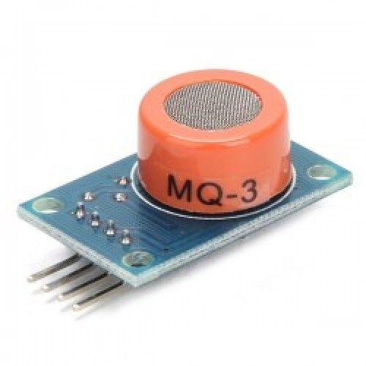

Figure 2.1

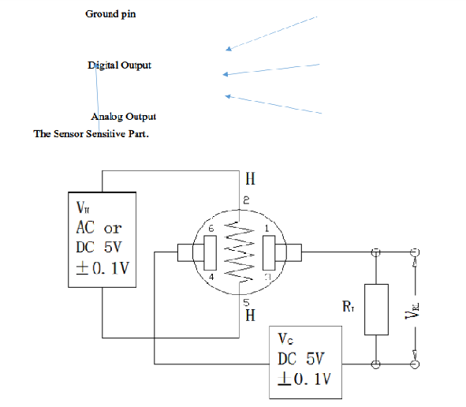

Figure 2.2

Therefore, as the gas concentration increase the conductivity of the sensor will increase and so does the sensor output voltage. However, this relationship is not linear. This sensor resistance is between pins 6&4 and 1&3 and a loop voltage is applied between the series of the sensor resistance and the load resistance. The sensor output voltage is the voltage across the load resistance. The load resistance is used to change the sensitivity of the sensor. A very high resistance, reduce the sensor sensitivity and small changes in the concentration of the gas would not be noticed. MQ-3 sensor has a load resistance of the sensor detect the gas concentration from a range of 300-10,000PPM. When the input voltage to the MCU is equal to or more than 2.0V, the MCU starts the audiovisual alarm. Although the relation between gas concentration and sensor voltage is not linear, there are ranges of sensor output voltage with constant gradient i.e. between 2.0V and 2.5V, for every increase of 20 PPM in gas concentration there is an increase of 0.1V. Thus gas concentration for any other voltage is through extrapolation from the known values of sensor voltage and gas concentration.

**2.3.1 Introduction**

A microcontroller (MCU) is a microprocessor with memory, input and output (I/O) pins and other additional peripheral features such as Timers/Counters on one chip depending on the type of the microcontroller. The MCU is mid-range microcontroller of the PIC family of microcontrollers produced by Microchip Technology Incorporation. It is a 8-bit, flash memory based, 20 pins CMOS MCU with nano Watt technology. It has a RISC CPU with 35instructions. The additional peripherals on the MCU, include; ADC Module, Analog Comparator Module, Timers/Counters, In-circuit Serial Programming, Enhanced Capture, Compare, PWM+ module and Synchronous Serial Port (SSP). It has Low power features and other special features such as; Precision Internal Oscillator (with a maximum speed of 8MHz), Power Saving Sleep mode, Wide Range of Operating Voltage (2.5V-5.5V), Power On Reset, Flash memory with 100,000 writes among other features.

**2.3.2 The MCU Architecture**

The MCU uses Harvard Architecture, data and program are accessed via separate data bus. The MCU can be divided into two part; the program execution section and the register processing section. The program execution section consists of the program memory, instruction register and the control logic. MCU has a 13 bits program counter thus 8K * 14 of program memory but only the first 4K of memory is implemented.MCU uses 14 bits instruction. Thus the code written should not exceed 4K.The register processing section consists of the static RAM and the Arithmetic and Logic Unit(ALU). The ALU uses a register called the Working Register which is used to temporary store data during execution. All other register used by the CPU are stored in the RAM which is arranged in 4 Banks each of 128 register each 8 bits. There two type of registers; Special Function Register (SFR) and General Purpose Register (GPR). The SFR are used for controlling processor operations and showing the status of the processor. These SFR are mapped in the first32 locations of each banks. Such SFR are STATUS, INTCON, OPTION_REG, TRIS and the PORT registers. The GPR space holds the user defined variable. The PIC uses the port registers (PORTA, PORTB and PORTC) to get data from the peripherals attached to it and to output data to the peripherals attached to it. The PIC has 18 general purpose I/O pins but one pin is an input pin only. The pin functionality as a General purpose I/O depends on whether a peripheral feature on that pin has been enabled. A pin configured as input for the comparator module cannot be used a digital input pin.

**2.4 LCD Display**

The LCD will be used for display of the gas concentration. This LCD displays alphanumeric characters (letters, numbers and symbols) which can be used to convey adequate information concerning the gas concentration status. The fact that it is built around the controller makes the LCD a smart device .The LCD has controls lines and data lines which makes it possible to send information for displaying on the LCD by putting the controls lines and data lines high or low. Therefore, the LCD can be interfaced to the microcontroller pins and information be sent to the LCD by controlling the microcontroller. Figure 2.3 shows the LCD pin out of each pin.

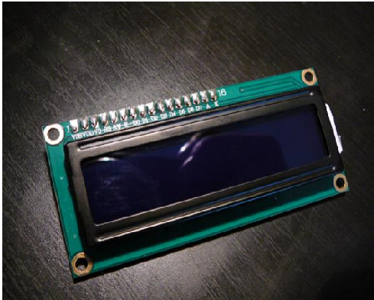

Figure-2.3

The 16*2 display means that only 2 lines of 16 characters can fit on the LCD display screen. The LCD has an integrated 80 characters display data buffer (DD RAM Data Display RAM) and an integrated character generator (CGROM-Character Generator ROM). It has also CGRAM- Character Generator RAM for user defined characters. The LCD is 13accessed through the instruction register or the data register. When sending commands such turning the display off, the command is sent to the instruction register through the data lines while when sending data, the data is passed to the data register through the data lines. The two are differentiated with the RS control line. When RS=0 and R/W=0, the controller sees the data placed on the data lines as a command and when RS=1 as the data to be displayed on the LCD. When data or command value is placed on the data lines it sent to the LCD when an Enable pulse signal is sent the LCD. An Enable pulse signal is sent when EN pin is pulled HIGH and then LOW with a small delay of about 500ns between. However, a microcontroller running at an instruction cycle of 1MHz will provide the necessary delay between putting EN HIGH and LOW.

The characters are displayed by sending their ASCII s value to a DDRAM address location through the data register and the CGROM generates the specified character to be displayed at that location. The LCD is used in 8 bit mode and all the 8 data lines (D0-D7) are connected to PORTC pins. The LCD can be used in 4 bit mode where only D4-D7 pins are used to transfer data and commands. Although this safes the MCU pins for other peripherals, data can only be sent in nibbles thus requiring more lines of code and takes more time to executes compared to the 8 bit mode where data is sent in bytes.

**2.4 Buzzer**

The buzzer used is Piezoelectric Active Buzzer. It uses the inverse relationship of piezoelectricity. When an alternating current is applied to piezoelectric material such as Piezo ceramic, they stretch and compress depending on the frequency of the signal producing a sound. The active Buzzer has a built in oscillator circuit and when applied with DC voltage will produce a consistent sound.

**2.5 Power Supply Unit**

The sensor, Buzzer and the MCU are require a 5V D.C voltage for powering up. Such a power supply is design using a 5V voltage regulator. The 5V power supply can be achieved using the circuit shown in Figure 2.6

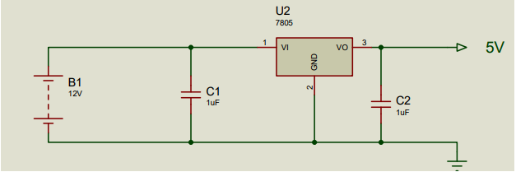

Figure 2.6

The circuit uses a 7805 voltage regulator which output 5V. Capacitor C1 filters out the noise from source voltage which is 9V battery by shorting the AC signal in the source voltage into the ground and allowing the DC signal only to pass. Capacitor C2 is used to filters out any AC signal in the output DC voltage.

**CHAPTER-3**

**DESIGN METHODOLOGY**

**3.1 Hardware Design**

The specifications of the cooking gas leakage detector are being to detect a LPG gas leakage and give an audiovisual warning. The detection system also has an alarm acknowledgement button. Therefore, the following components are required to make the gas detector; MQ-3 Sensor, MCU, LCD Display, Buzzer, 2 RED LED, GREEN LED a Button and current limiting resistors.

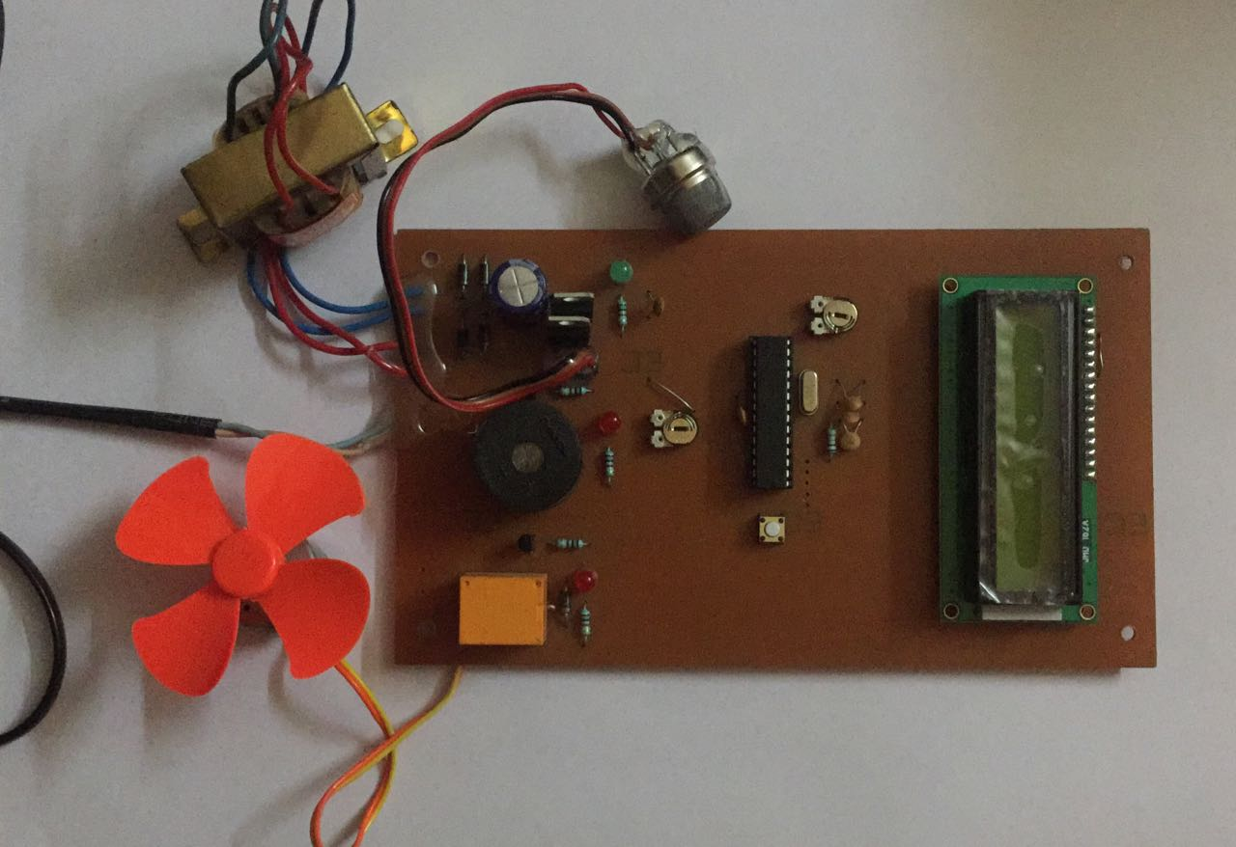

**3.1.1 MQ3 Gas Sensor**

The sensor is used to detect when there is a gas leakage and the amount of the gas concentration by giving out a voltage output depending on the gas leakage concentrationInterfacing the sensor to the MCU .The sensor gives an analog voltage input to the MCU. A potentiometer is used to simulate the analog voltage from the sensor.

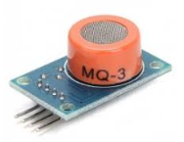

**3.1.1.1 MCU**

The microcontroller is the control unit. All the peripherals, Sensor, alarm, LEDs, LCD and button are connected to it through the interfacing pins. It monitors the input signal from the sensor. When the signal get above the trigger level, the MCU set off the alarm, blinks a red LED and display the concentration of the gas leakage on the LCD. When the signal is below the trigger level, a green LED is lit. When the device is powered up the MCU light a blue LED to show Power ON status. The various peripherals are interfaced to the microcontroller through the following pins as described in Table 3.1Figure 3.3 shows the interface of the various components to the PIC16F690 microcontroller on a pcb and Figure 3.4 shows fabricated circuit.

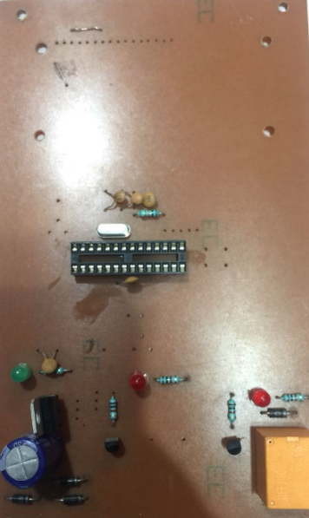

**3.1.1.2 LCD Display**

The LCD shows the numerical value of the gas concentration in Parts per Million. The LCD is interfaced to the microcontroller .The RW pin is permanently grounded because we will be only sending data and command to the LCD.

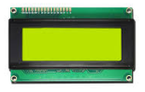

**3.1.1.3 Buzzer**

It gives an audio alarm when there is gas leakage. The buzzer is interfaced to the MCU through pin gives a visual alarm when there is gas leakage. Blinking of a red LED indicates that power supply is on and when the gas leakage is detected then green & red both LED’S glow. The LED are interfaced to the microcontroller through a current limiting resistor.

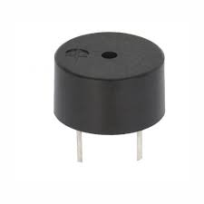

**3.1.1.4 Button**

It used to acknowledge the alarm and it is connected to the microcontroller pin .

**3.1.1.5 Power Supply**

The power supply used for powering the detector.

**3.1.2 Circuit Diagram**

**[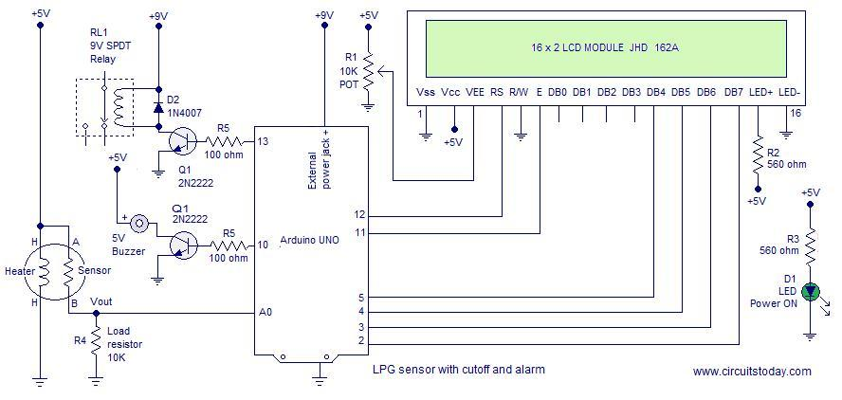](http://www.circuitstoday.com/wp-content/uploads/2014/11/lpg-sensor-using-arduino.jpg)**

**3.2 Software Design**

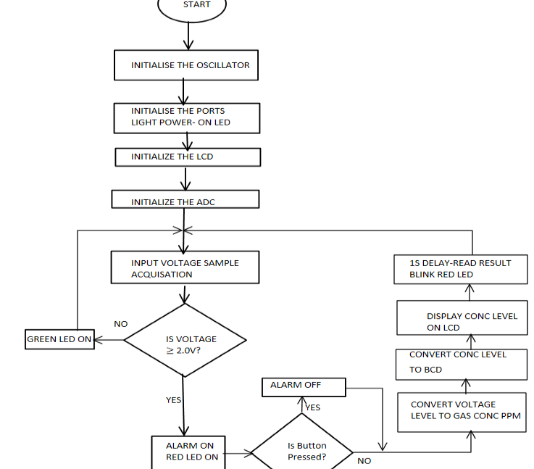

**3.2.1 Programming the ARDUINO**

**PROGRAM-**

#include<LiquidCrystal.h>

int mq2=A0;

intrel=13;

intbuz=10;

int d;

float p;

LiquidCrystallcd(12, 11, 5, 4, 3, 2);

void setup()

{

pinMode(rel,OUTPUT);

pinMode(buz,OUTPUT);

digitalWrite(rel,LOW);

digitalWrite(buz,LOW);

lcd.begin(16,2);

}

void loop()

{

d=analogRead(mq2);

lcd.setCursor(0,0);

lcd.print("LPG SENSOR");

if(d<60)

{

p=0;

}

else

lcd.setCursor(0,1);

lcd.print(p);

lcd.setCursor(5,1);

lcd.print("%");

if(p>=30)

{

digitalWrite(rel,LOW);

digitalWrite(buz,HIGH);

lcd.setCursor(9,1);

lcd.print("TRIP");

}

else

{

digitalWrite(rel,HIGH);

digitalWrite(buz,LOW);

}

delay(500);

lcd.clear();

}

**IMPORTANT**

* MQ2 sensor requires a 24 hour preheat for stable operation.
* The heating coil of the MQ2consumes around150mA and so it is wise to power the coil from a separate source.
* 5V required at other parts of the circuit can be tapped from the arduino board.
* The arduino board can be powered through the 9V power supply jack.

**CHAPTER-4**

**RESULTS**

The objective of the project was to design and implement a microcontroller based cooking gas leakage detector capable of detecting gas leakage and giving an audiovisual warning. The detector has been designed around microcontroller and MQ-3 sensor. According to the design, the detector is supposed to show there is gas leakage when the sensor voltage is &gt;=2.0V. When the simulated circuit for the detector is ran, with the potentiometer being 0% (0V) the green LED lit showing there is no gas leakage. This is the same case when the practical circuit is powered ON and no gas is released. In absence of the gas, the sensor resistance is high such that the output voltage is almost zero. The microcontroller is programmed such that as long as the voltage from the sensor is below 2.0V it lit the green LED to show that there is no gas leakage. When there is a gas leakage, the sensor voltage should increase due to the increase in the sensor conductivity. When the potentiometer is at 40%, immediately the red LED glows and the alarm goes off and the fan starts. The LCD starts showing gas concentration starting from 300ppm. The same thing happens when the gas is released constantly. The sensor output voltage increase gradually and when it reaches 2.0V, the alarm systems goes off. The sensor voltage increases almost to 5V with the LCD showing the gas concentration levels in ppm. This is because the gas molecules gets adsorbed on the Tin oxide surface layer and its oxidizing effect leads to increased concentration of electrons which leads to increased conductivity. The gas concentration for any voltage from the sensor is arrived at through interpolation. Although the relationship is not linear, there are intervals of, known gas concentration and sensor voltage that can be used to convert any other value of sensor voltage to a corresponding gas concentration. This algorithm has been programmed in the microcontroller and this is what makes the detector to be very accurate and precise in displaying the gas concentration level. The use of a microcontroller helps us to write a conversion algorithm which makes the detector to be very accurate in displaying the gas concentration level. When there is a gas leakage, the sensor voltage should increase due to the increase in the sensor conductivity.

**CHAPTER-5**

**CONCLUSION AND RECOMMENDATIONS**

**5.1 CONCLUSION**

The objective of the project was to design and implement a gas detector capable of giving an audiovisual warning when there is a gas leakage. The detector has been designed that uses a microcontroller and a MQ-3 gas sensor. The detector shows a red LED to show that there is no gas leakage. When there is a gas leakage the detector flashes a red & green, and sound an alarm. The detector has an alarm acknowledgement button that can be used to put off the alarm when necessary. The detector used a LCD to show the concentration of the gas leakage. The sensor is capable of showing a gas concentration from 300ppm to 10,000ppm. The use of a microcontroller makes the detector to have high accuracy in displaying the gas concentration according to the relationship that exist between the sensor voltage and gas concentration. The detector is low cost. The components that goes into making the detector does not exceed 1600KShs. If this is done with mass production then the detector can go for a price of 1500ksh which would very easily affordable and competitive in the market. The objective of designing a highly accurate low cost a microcontroller based cooking gas leakage detector has been well achieved.

**5.2 RECOMMENDATIONS**

Despite how this project might look good it is still wanting. The use of an alarm, LED and LCD as the alarm system is not enough. This require a person presence in the vicinity to be notified when there is gas leakage. This detection system can be improved by including a GSM module for sending sms alert to a mobile phone. This way, wherever someone is, he can be notified when there a gas leakage. To improve the safety of people and property, the sms alert can be sent to the relevant authority like the fire brigade department to deal with the gas leakage issue if the gas leakage as reached very high concentration. To take this gas detection system to new perfection, the gas can be supplied with smart regulator which can be turned off remotely or by sending a signal. Thus when detector has detected gas leakage even before it sound the alarm and send the alerts, the microcontroller should send a signal to switch off the gas. To effectively implement all this good design features a higher level microcontroller would be useful. microcontroller is a midrange microcontroller by Microchip. Microchip have PIC18 series which are higher level microcontroller with more pins and features such as priority interrupts which would help to easily incorporate the improvement to this gas leakage detection system.

**CHAPTER-6**

**LIST OF FIGURES**

1. **MQ3 SENSOR**

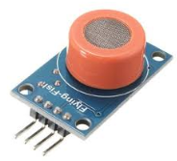

**2-LED’S**

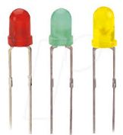

**3-TRANSFORMER**

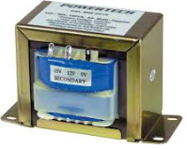

**4- BUZZER**

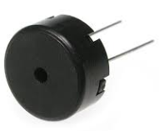

**5- PCB BOARD**



**6- RESISTORS**

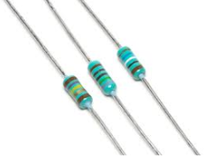

**7- CERAMIC CAPACITOR**



**8-CYLINDRICAL CAPACITOR**

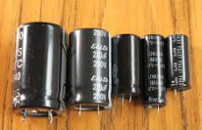

**9- EXHAUST FAN**



**10- WIRES**

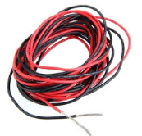

**11- ARDUINO**



**12- MOTOR**



**13-POTENTIOMETER**

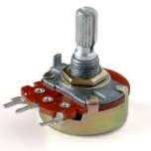

**REFRENCES**

[1] E. T. Goerge, Fuels and Lubricants handbook: technology, properties, performance and testing, 2nd Edition. West Conshohocken, Pa : ASTM International, 2003.

[2] E. Hahn, “LPG Gas Blog,” LPG Gas Blog, 2016.

[3] “Lower-(LEL)-&-Upper-(UEL)-Explosive-Limits-.pdf.”

[4] X. Liu, S. Cheng, H. Liu, S. Hu, D. Zhang, and H. Ning, “A Survey on Gas Sensing Technology,” Sensors, vol. 12, no. 12, pp. 9635–9665, Jul. 2012.

[5] Great Britain and Health and Safety Commission, Dangerous substances and explosive atmospheres: Dangerous Substances and Explosive Atmospheres Regulations 2002. Sudbury Suffolk [England]: HSE Books, 2003.

[6] Zhengzhou Winsen Electronics Technology Co., Ltd “Flammable Gas Sensor (MQ-6 MODEL) MANUAL,” no. VERSION 1.3, p. 7, May 2014.

[7] C. Sansone, S. Manfredi, E. Di Tucci, S. De Vito, G. Fattoruso, and F. Tortorella, “A novel approach for detecting alerts in urban pollution monitoring with low cost sensors,” in Measurements and Networking Proceedings (M&N), 2013 IEEE International Workshop on, 2013, pp. 89–93.